***Computational Analysis of Potential DNA Nanoscale Biosensors.***

**Introduction and Previous Research:** The study of viruses was always complicated and stayed so to the current day. The discovery of viruses was initiated when porcelain filters were created, and the experiments proved that the infectious particles are different from the bacteria. Virions, single virus particles, vary in the size range from 20 nm to 250 nm in diameter, which for the longest time, caused a lack of images until the invention of the electron microscope. A virion consists of RNA or DNA surrounded by a protein shell that has an infective form of a virus; it is a primary goal in current medicine to find a way to detect them in living organisms for a faster and efficient diagnosis.1 Consequently, the research that I am doing is trying to make progress in this area by creating nanoscale biosensors.

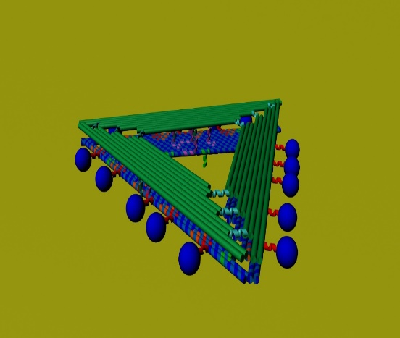 I work with DNA origami, which is a type of self-assembled structure constructed from a single-stranded DNA scaffold that is folded into a specific shape with “staple” DNA strands.2 At first, I worked on synthesizing various versions of triangle-shaped structures. I synthesized floppy triangles with Methylene Blue redox reporters on the sides of them, and I also synthesized complementary rigid triangles, the purpose of which was to attach to the floppy triangles. This attachment resulted in a conformational change, which was monitored by the Square Wave Voltammetry (SWV) electrochemical technique. SWV showed the electron-transfer from origami (that bears redox reporters) to the gold electrode. The unique results have shown that it is possible to detect and analyze the binding-induced conformational change of DNA-origami with electrochemical origami biosensors.

This research project has shown some extremely significant data for the nanoscale field since this is the first-time electrochemical data was retrieved for DNA-origami assemblies. However, I believe that this project could have continued and brought even more useful knowledge to the field. **Aim 1. Return to this project and perform binding to the actual virus or virus-like particle (VLP) by introducing complementary strands on the triangles to the antigens on the virus.** Our lab has already tried to perform VLP binding with the “claw” assembly, but the structure was not performing correctly, forming a structure of letter T, rather than the claw itself. And the VLPs were already proved to bind to the triangle through the AFM images and electrophoresis through the work of other scientists.3 However, the binding experiments with the actual virus and electrochemical analysis still have to be done. I propose that once the binding sites on both triangles would be established with proper complementary strands that would fit both sides of the virus, the binding will occur if virus particles are added initially to the mixture of both types of triangles. Since working with viruses is dangerous and expensive, VLPs would be an optimal substitute. But even before directly with the materials, the experiment should be constructed and analyzed computationally. Even though we implement computational techniques for all of our projects because we need to synthesize sequences of DNA strands for the specific geometric model, which we call the “algorithm” process, we can still go further with current computational abilities.4 In this case, I believe we should try to construct the triangles and virus in VMD program and see how would they actually interact with each and if the binding can occur. Then, we can use Gaussian to calculate how much energy it would take for the proposed binding and then analyze if this binding could happen in the current presented system.

Figure 1.Representation of the binding of the floppy and the rigid triangles.

My new project consists of working on designing electrochemical biosensors, in the shape of a hinge. The structure of a hinge consists of two beams that are connected by the four DNA duplexes, called adjusters, since their length is modified from experiment to experiment. In the synthesis of these hinges, we also use redox reporters, Methylene Blue (MB), and Anthraquinone (AQ). AQ serves as a reference and is located on the “base” beam, which is the one connected to the gold electrode and MB serves as a measuring reporter of electron transfer and is located on the “arm” beam, that is further from the electrode and connected with adjusters 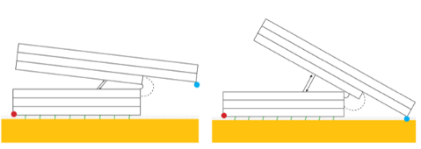to the “base” beam. The big picture of this project is to make biosensors that would bind macromolecular assemblies in biofluids. The difference between the first and the second projects is that for this one, we are trying to monitor the distance variable of the structure precisely. However, I currently experience issues with optimizing conditions of origami annealing, imaging, and its deposition onto the gold electrode. **Aim 2: Find the conditions at which the “hinge” positioners would give us precise information about the angle distance between the two beams.** The major problem in this experiment is the buffer solutions. For the unknown reason, sometimes buffer solutions would work great in the agarose gel experiments, and sometimes they would not. One assumption that I have is that the pH of the buffer changes and ruins the experiment, but when I tested the solutions with the pH meter, only a couple were lower than they should have been. Another assumption about this issue is that since I anneal our structures in the buffer that has a higher concentration of magnesium chloride than the buffer for the gels has, the difference can cause the malfunction, and that is why positioners do not show up on the gel. The accurate anneal of the hinges is crucial because we need the precise control of angle and distance between the beams of each hinge. Also, electrochemical deposition and redox reporter optimizations are vital because we want to achieve distance-based molecular measurements with an electrochemical output. Therefore, I propose that in order to understand the issues better, I need to employ computational techniques to understand the system’s interactions. For instance, use the VMD program to see how the molecule of the buffers interacts with the DNA-origami structure and see if there is a chance for any possible destruction.

Figure 2. Representation of the "hinge" positioner with different adjuster lengths.

**Broader Impact:** The funding of this research is crucial for future medicine because once there is better detection of viruses in vivo, there are better diagnostical approaches. That means more people would be saved before it is too late.

**References:** 1) Discovery and Detection of Viruses. *Lumen.* [Online]. <https://courses.lumenlearning.com/boundless-microbiology/chapter/overview-of-viruses/>. 2) Rothemund, P. W. K (2006). Folding DNA to create nanoscale shapes and patterns. Nature. 461, 74-77. 3) Wang, D., et al., Hierarchical assembly of plasmonic nanostructures

using virus capsid scaffolds on DNA origami templates. ACS nano, 2014. 8(8): p. 7896-7904. 4) Jabbari, H., Aminpour, M., and o Montemagno, C (2015). ACS Combinatorial Science. 17 (10), 535-547.